Dim_name_basics

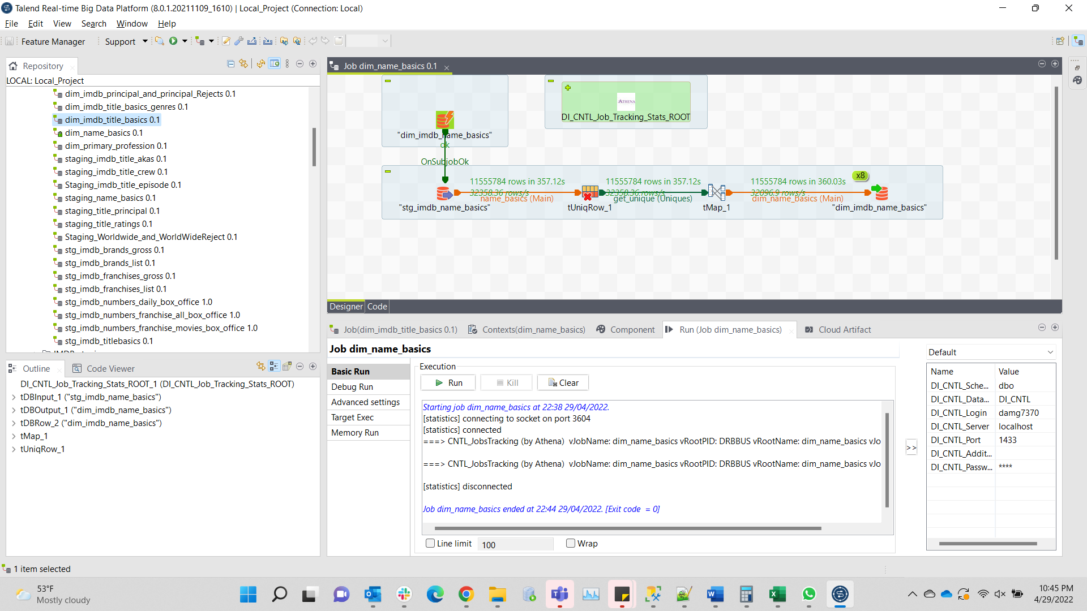

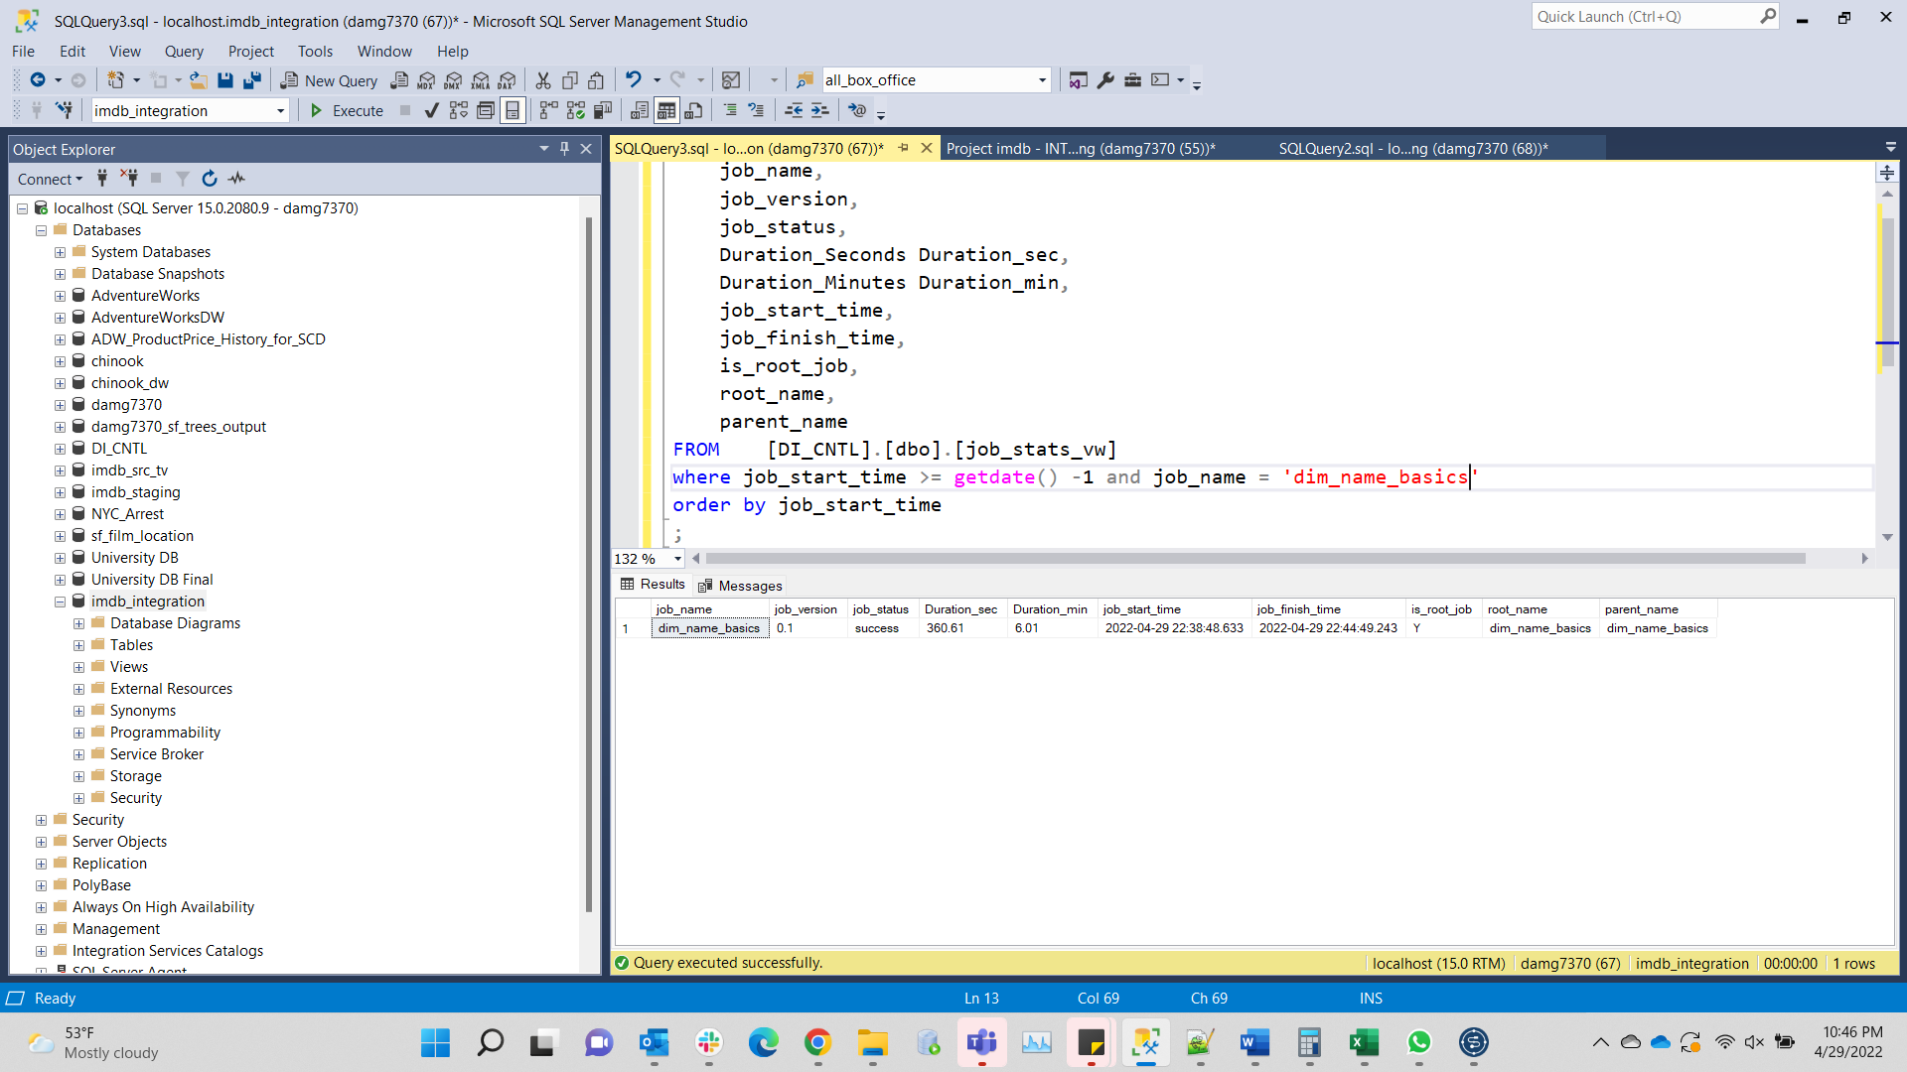

Dim_primary_profession

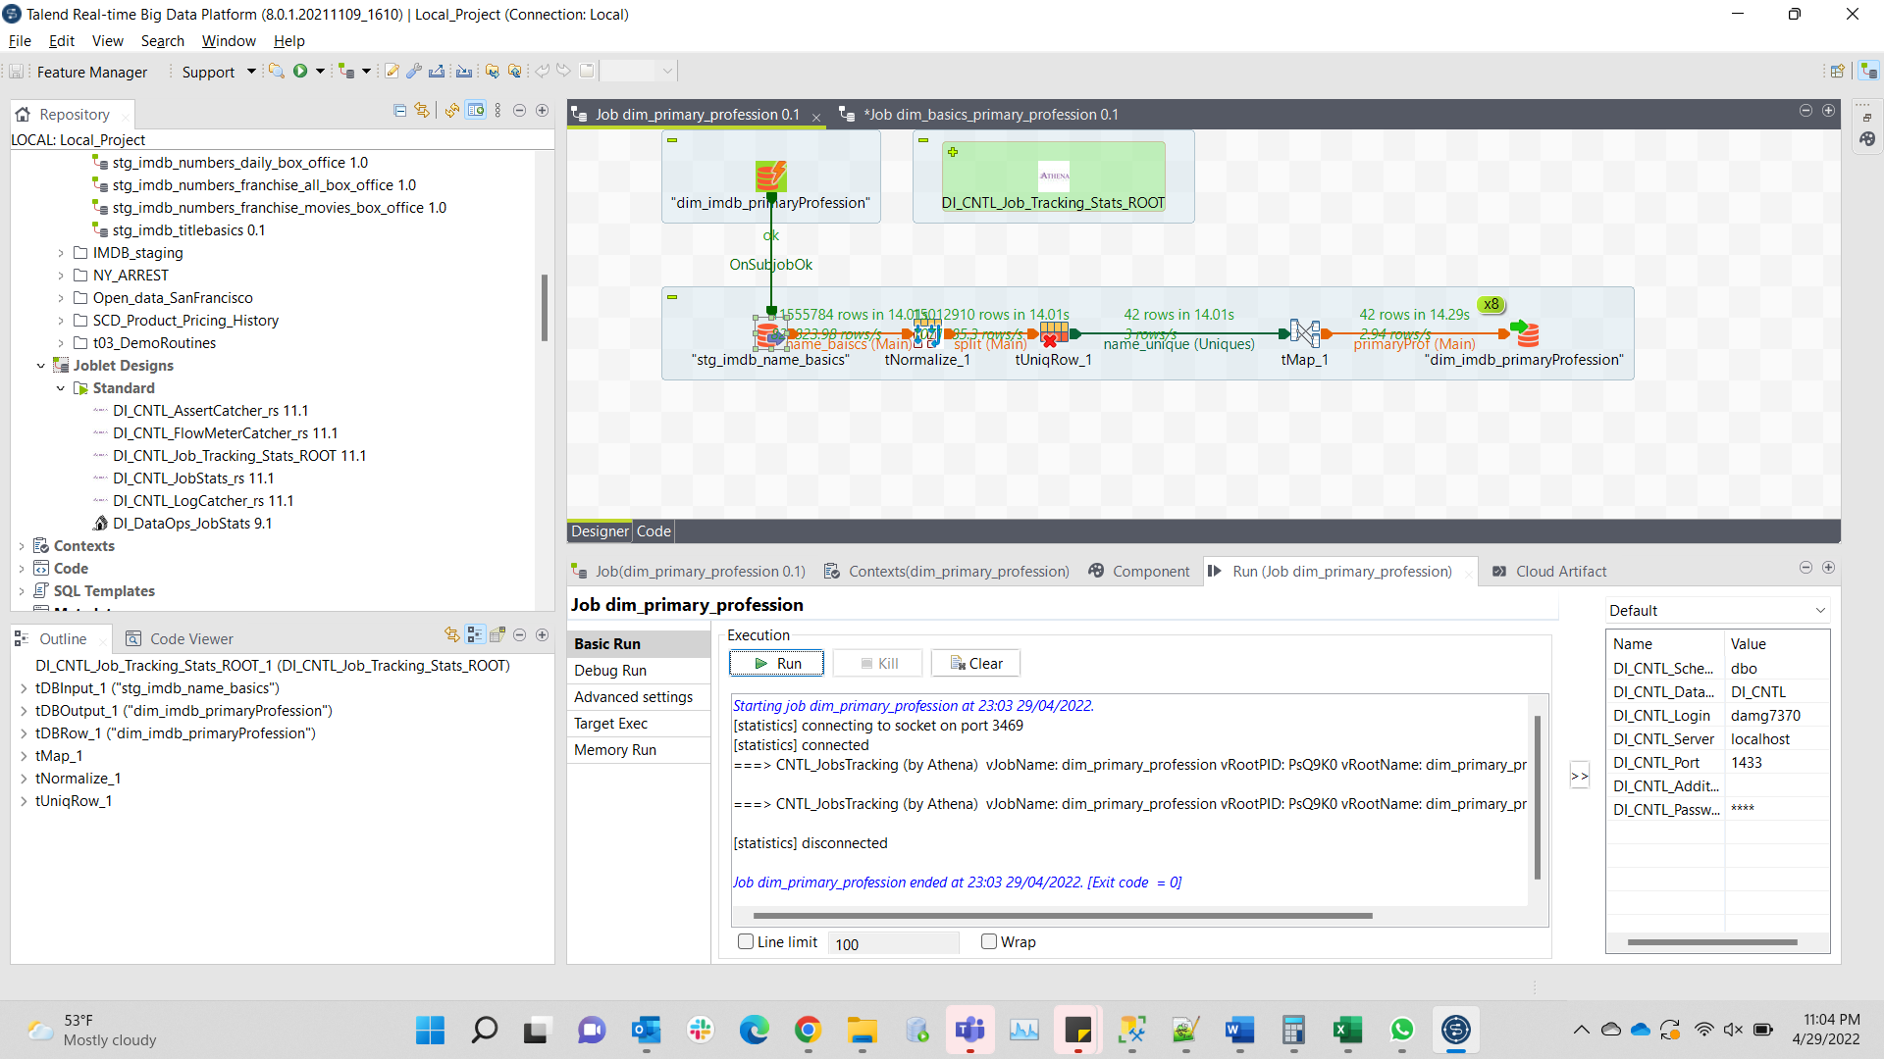

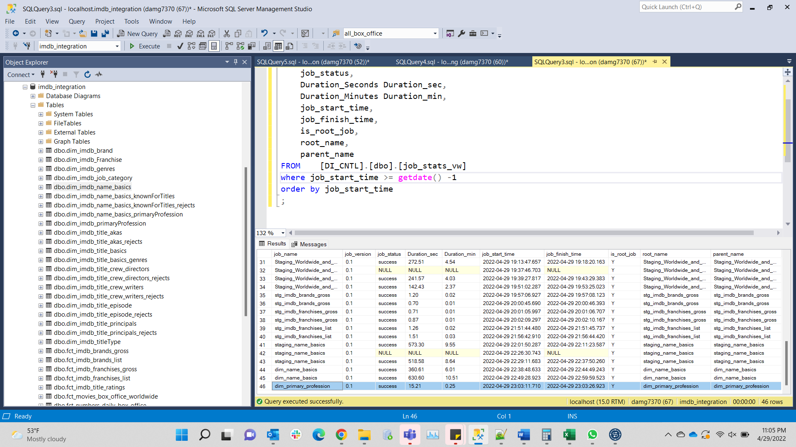

Dim_basics_primary_profession

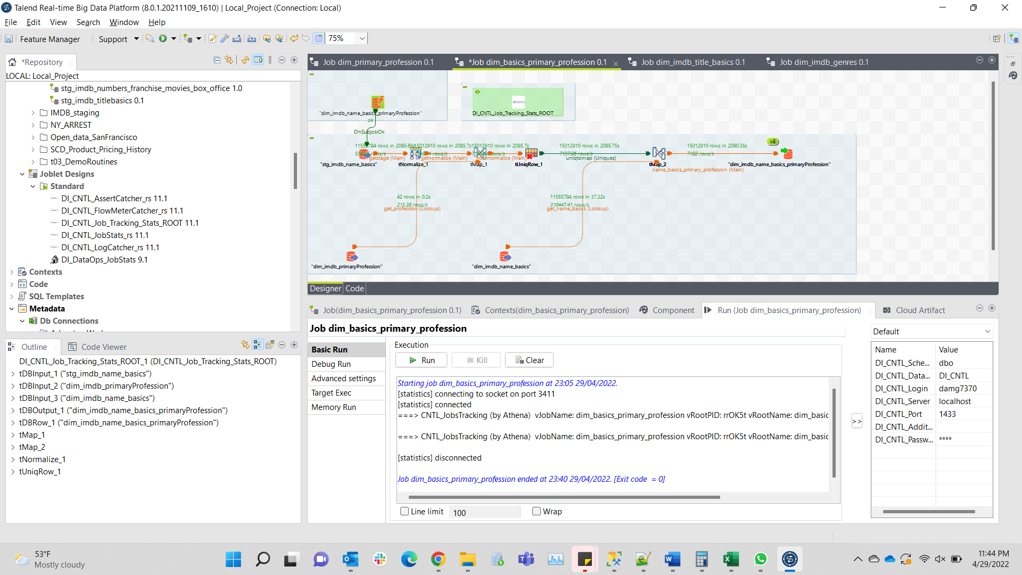

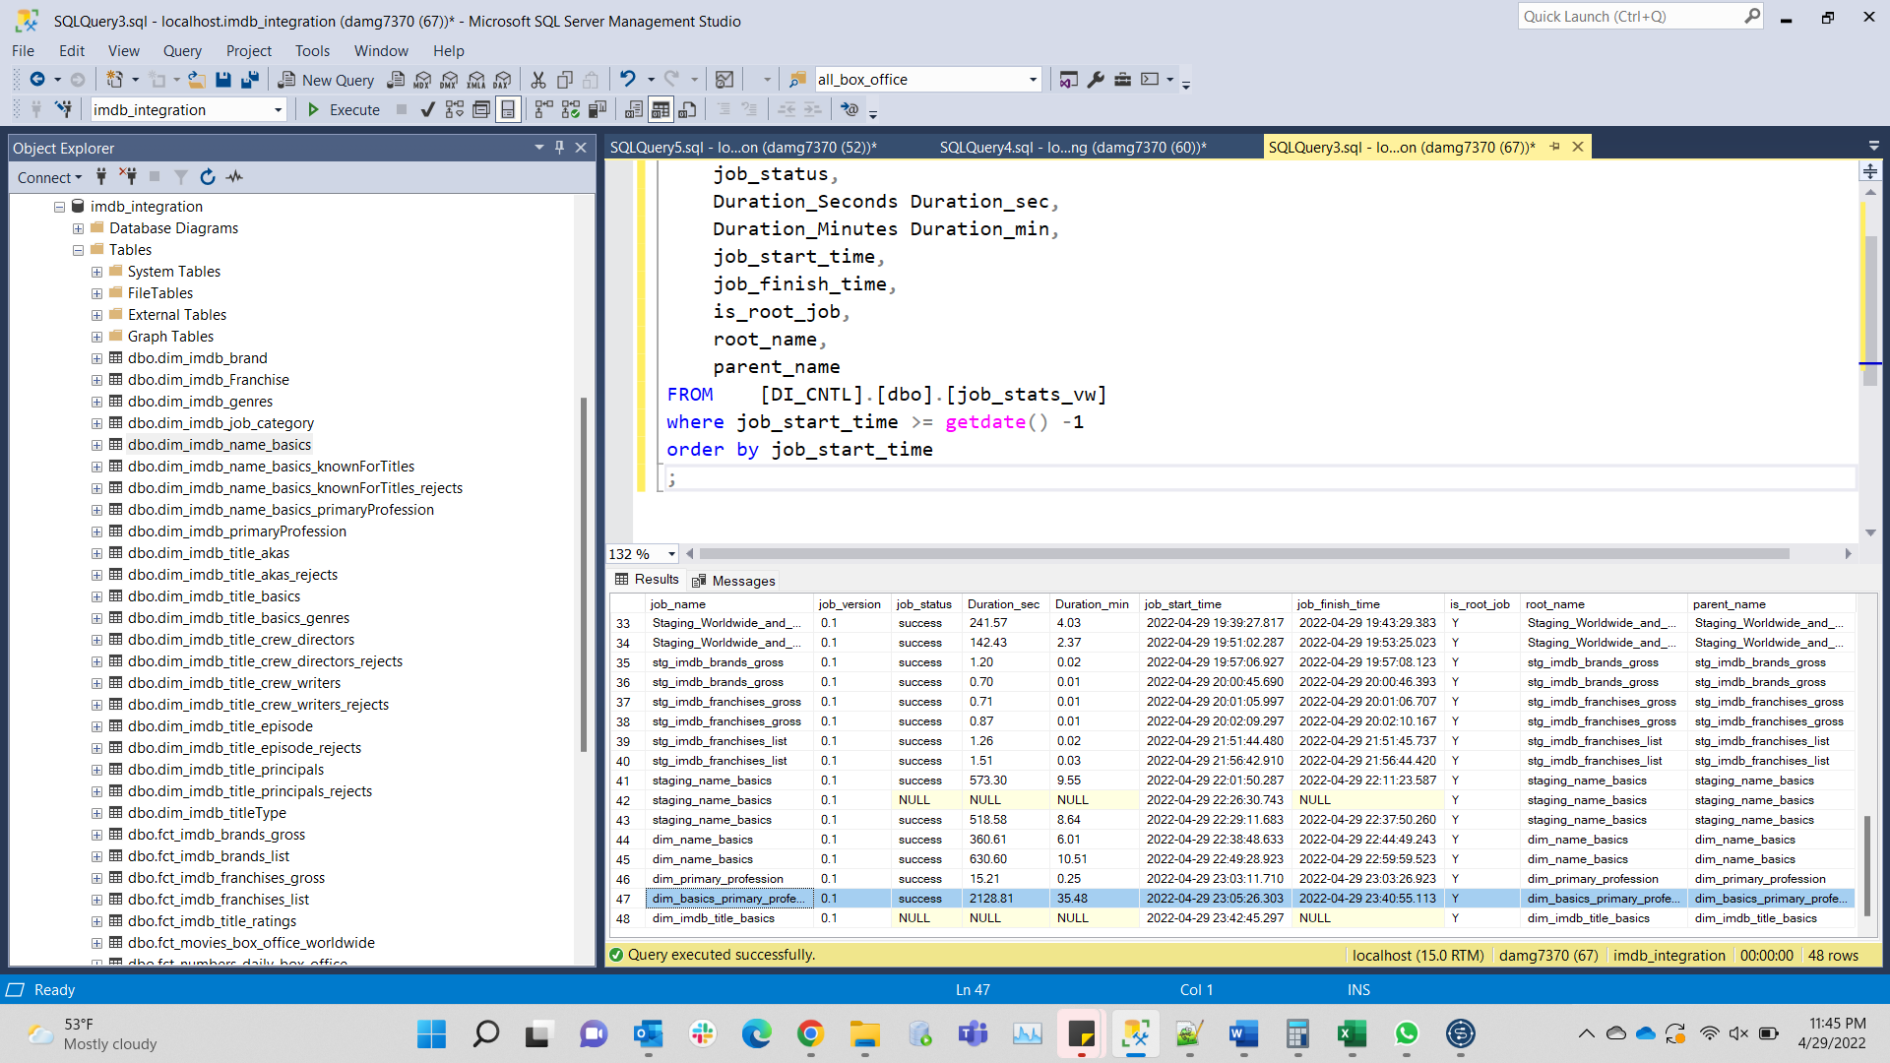

"Dim_imdb_title_basics"

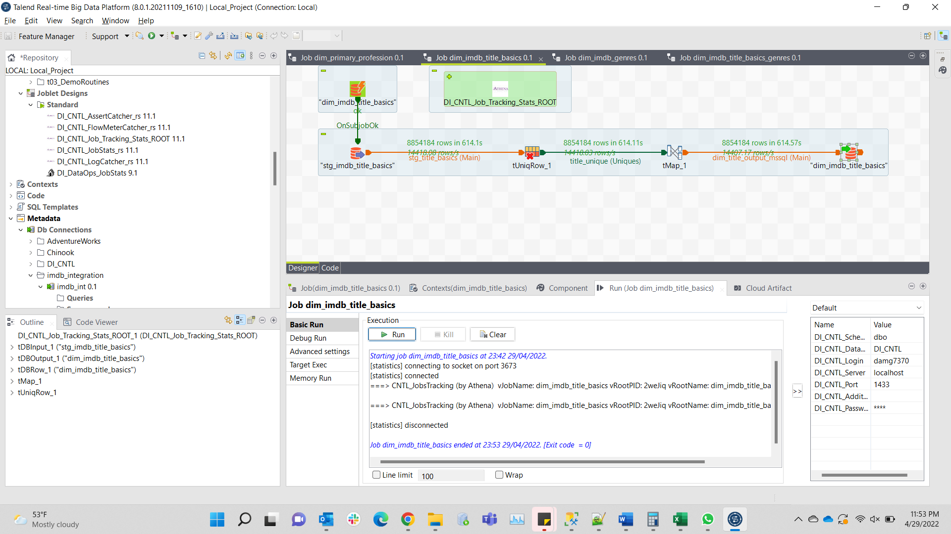

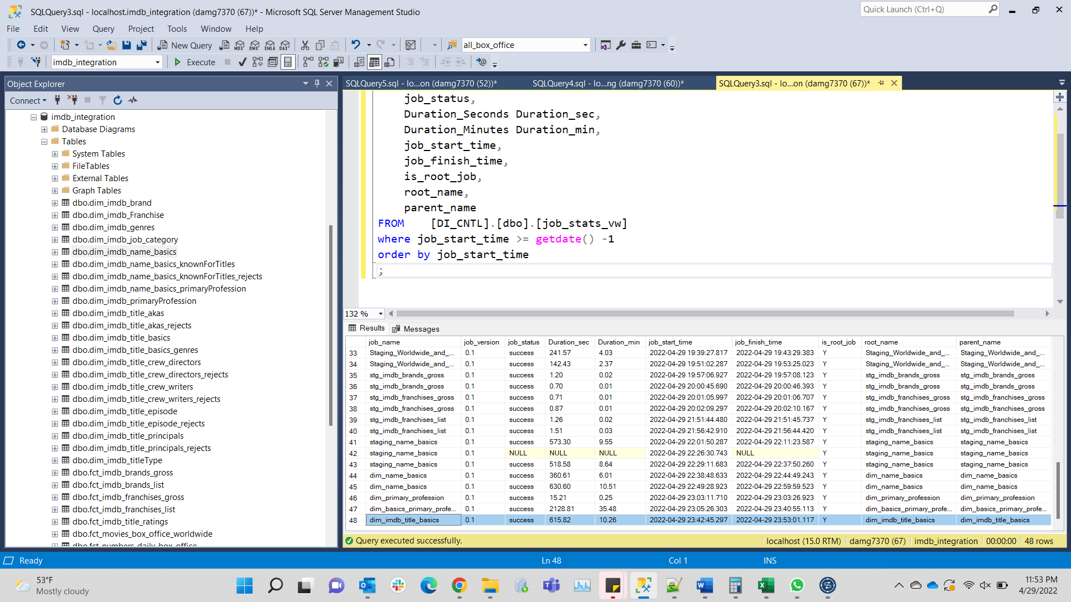

"Dim_imdb_genres"

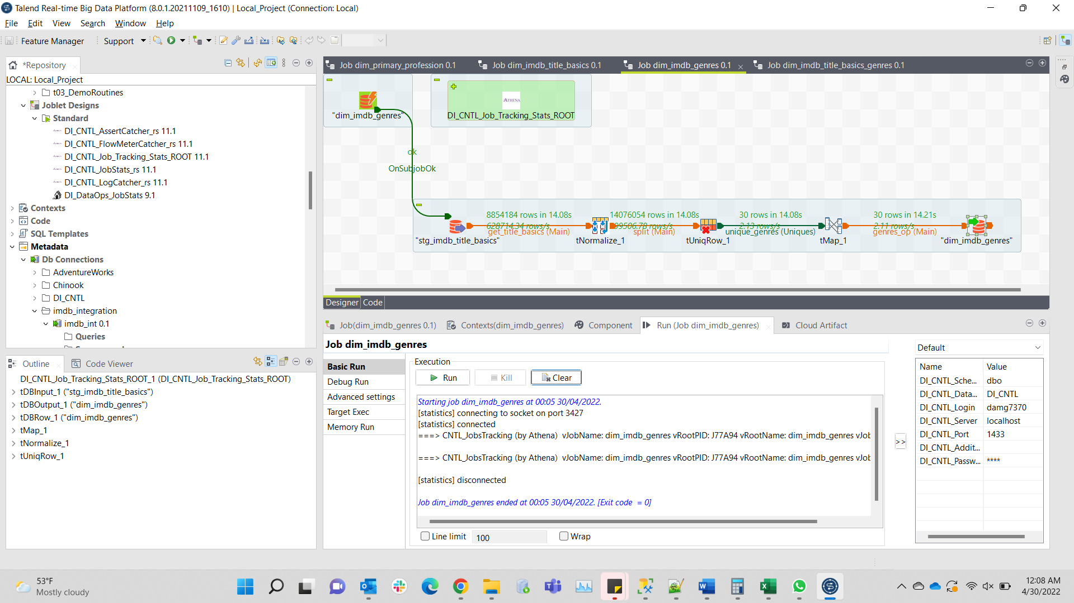

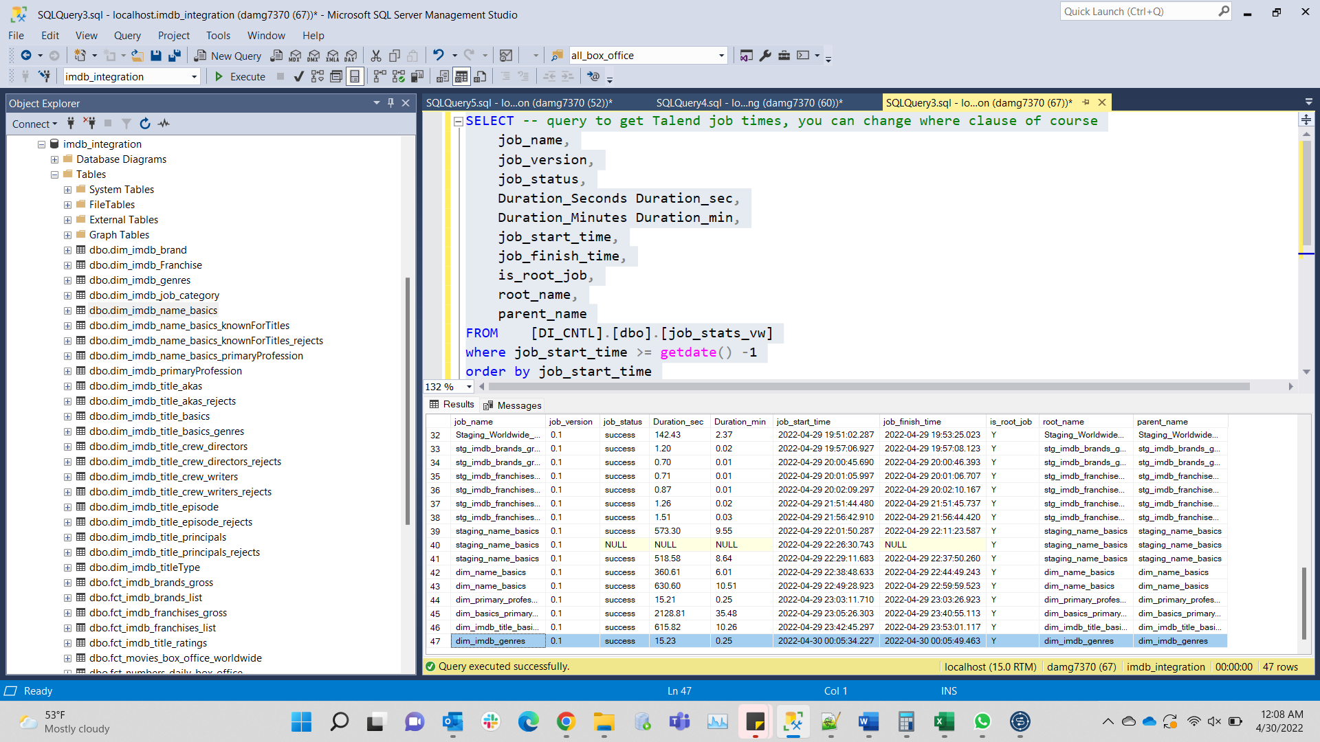

Title_basic_genres

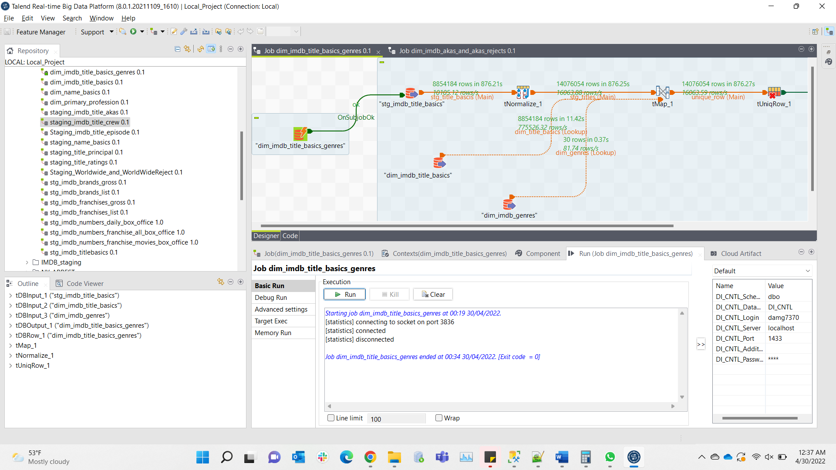

dim_imdb_title_crew_writers_and_writers_reject

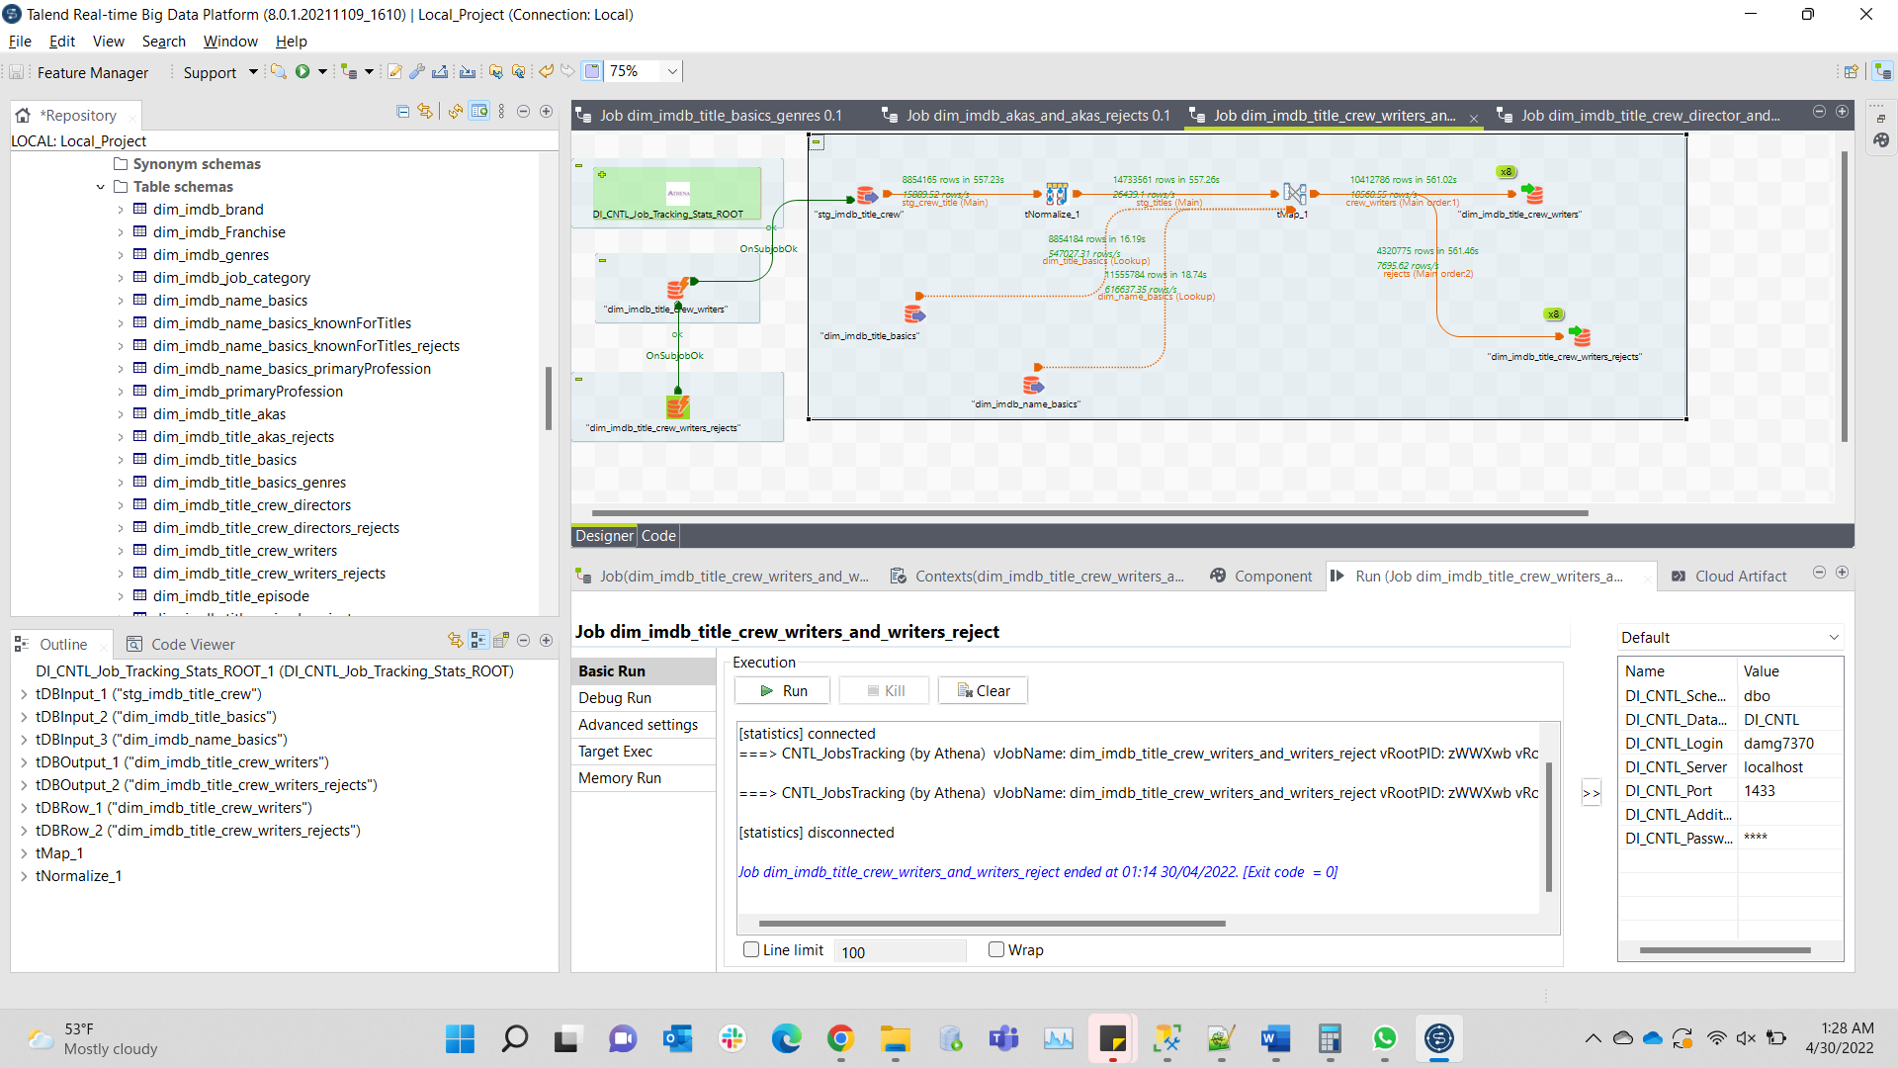

Dim_imdb_title_director_and_director_reject

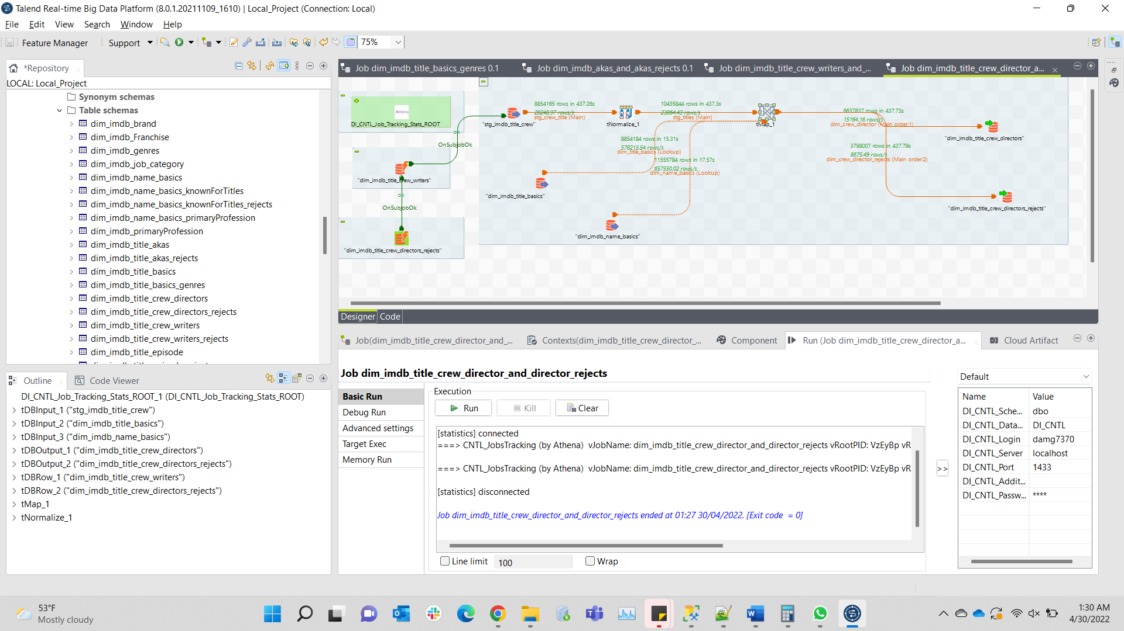

Know_for_titles_with_rejects

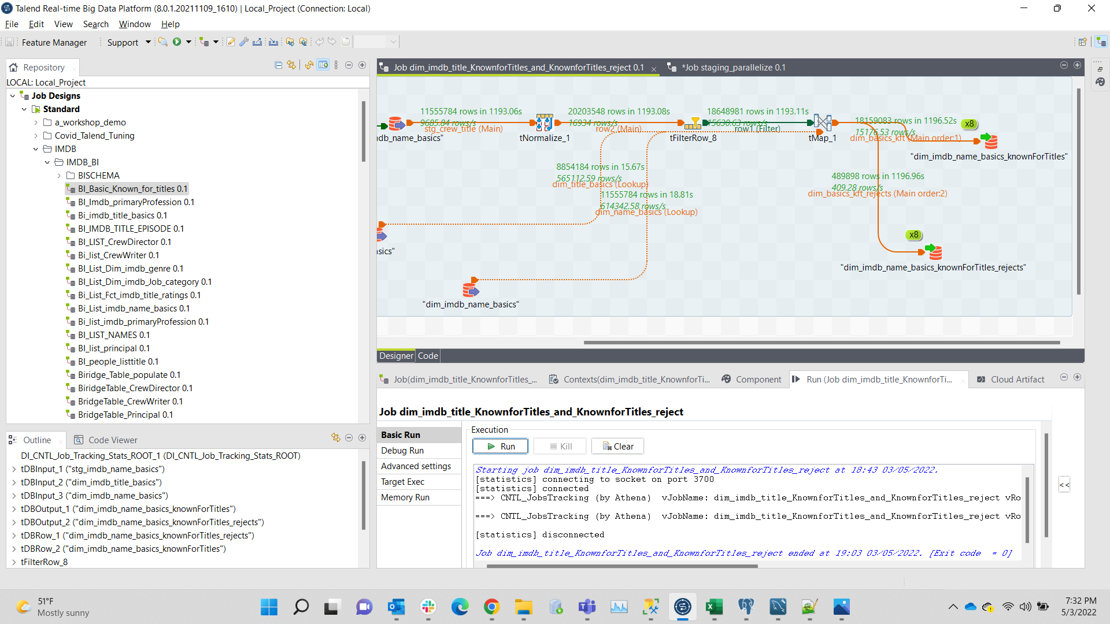

"dim_imdb_job_category"

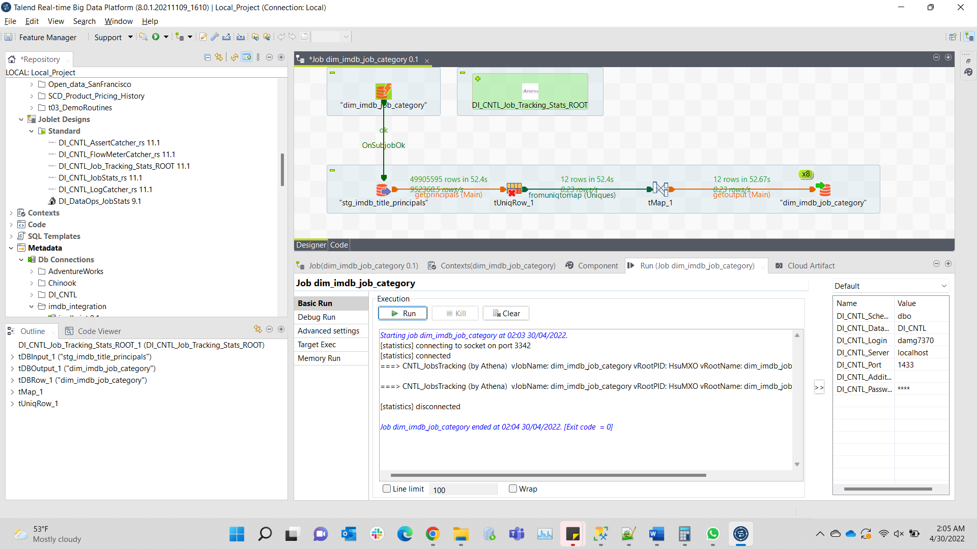

"dim_imdb_Franchise"

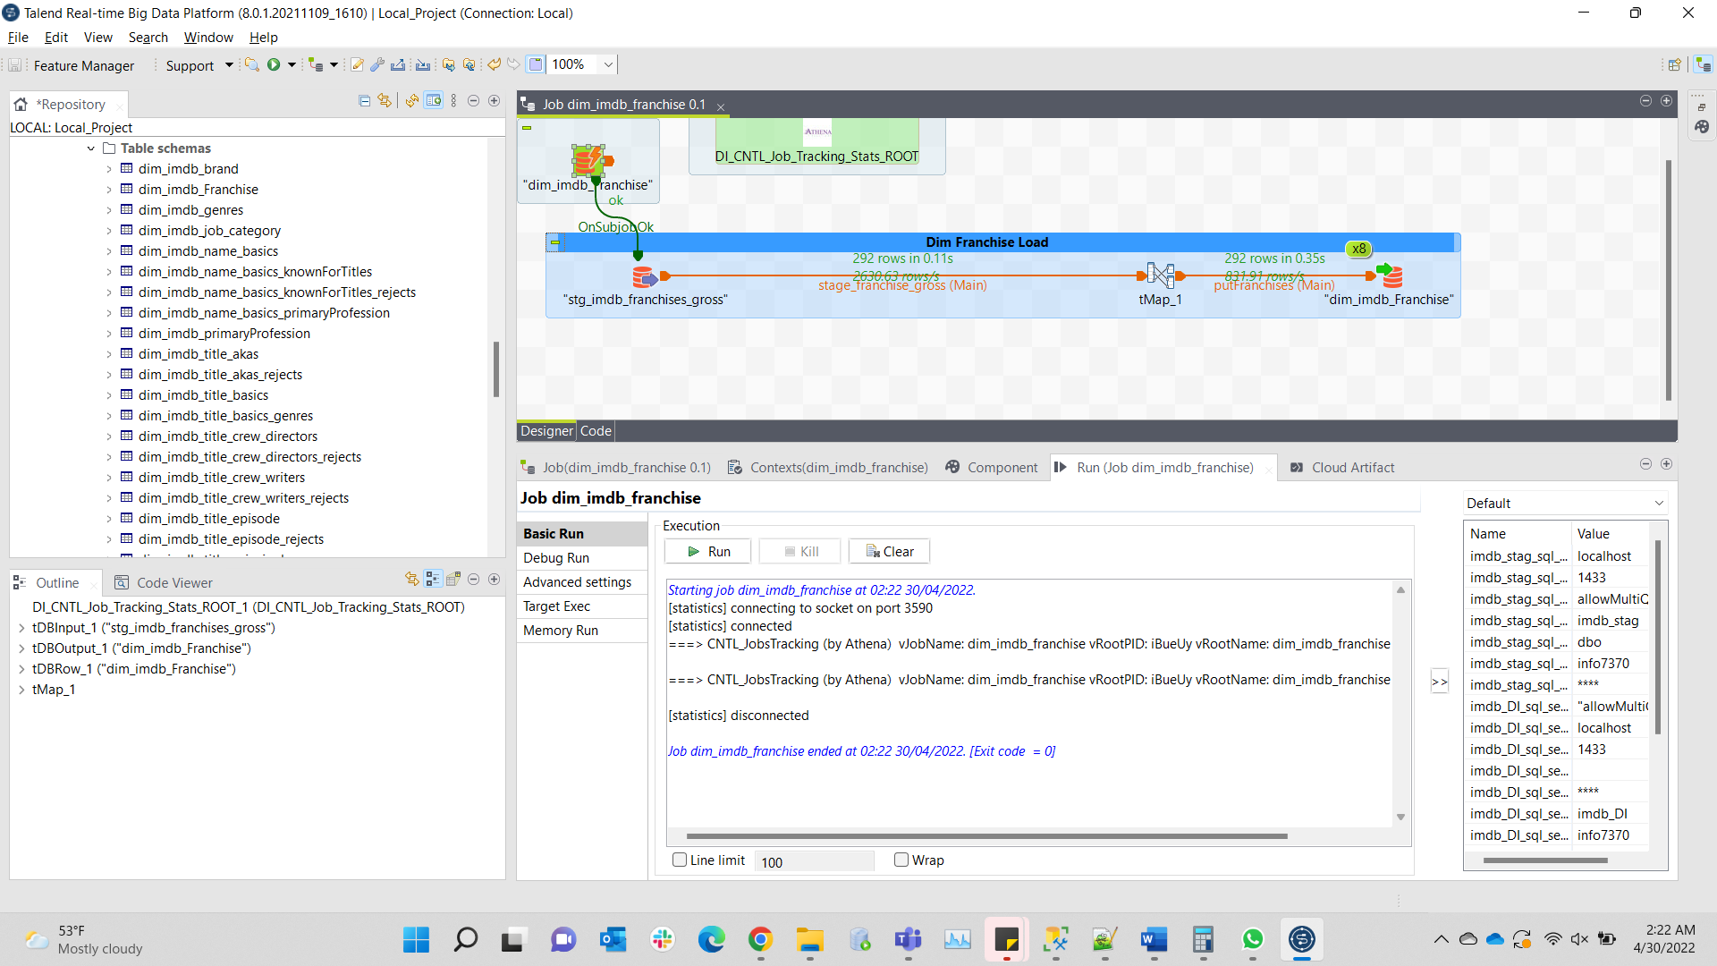

"Dim_imdb_brand"

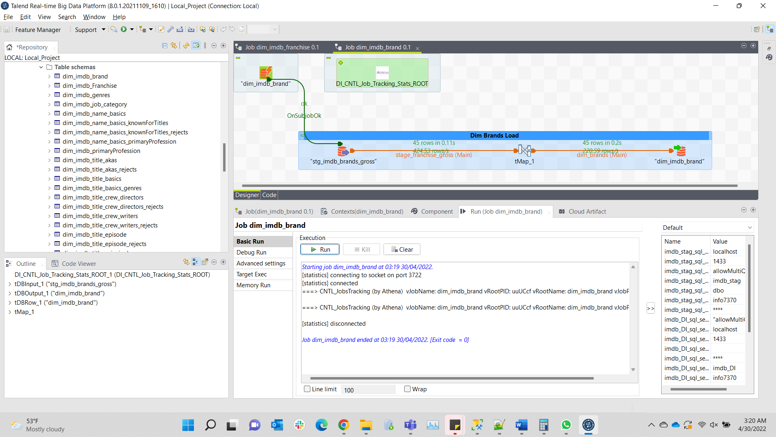

dim_imdb_akas_and_akas_rejects

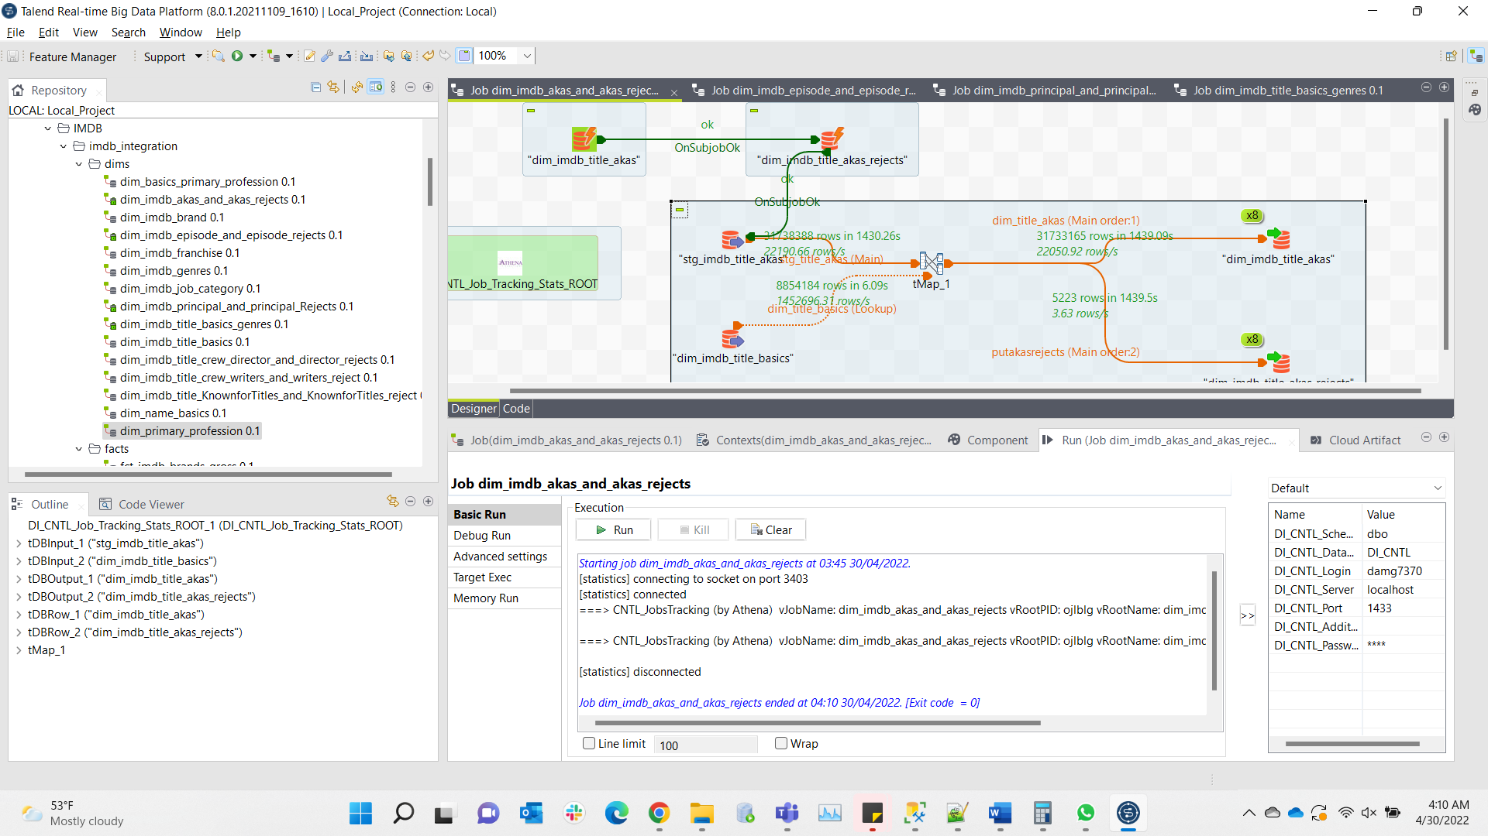

Dim_imdb_episode_and_episode_rejects

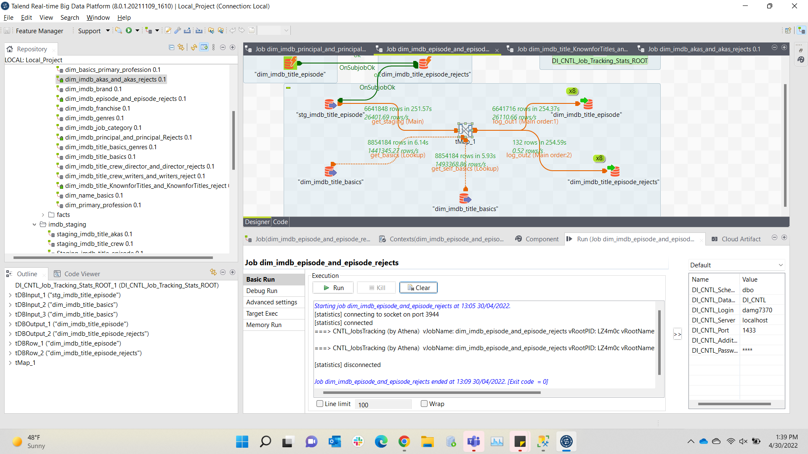

dim_imdb_principal_and_principal_Rejects

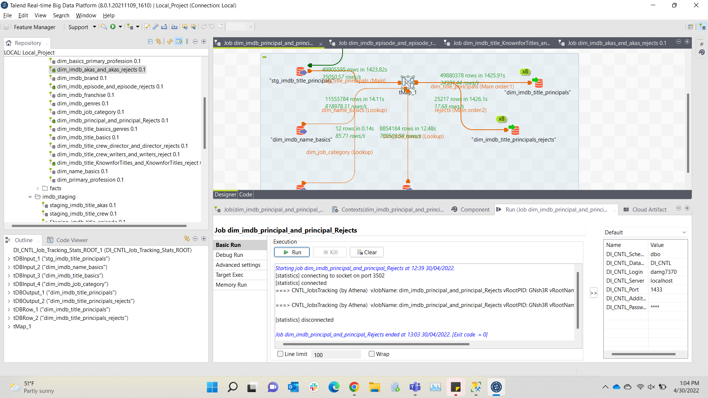

Dim_imdb_title_basics_genres

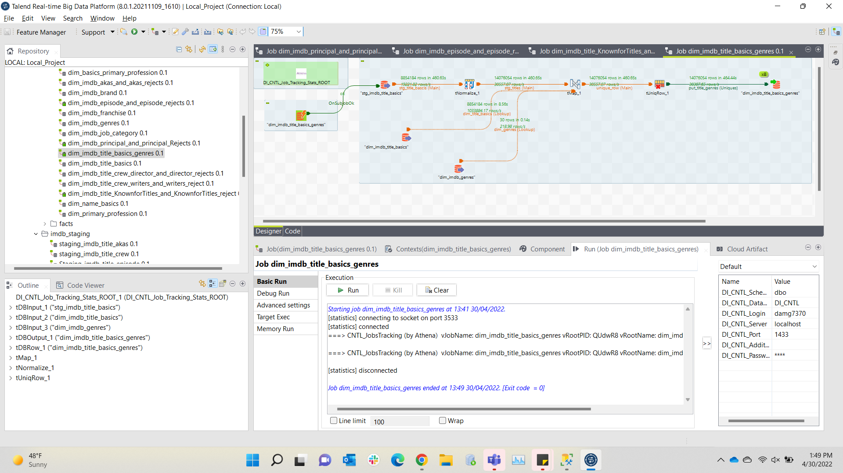

**Facts:**

Fct_imdb_brands_gross

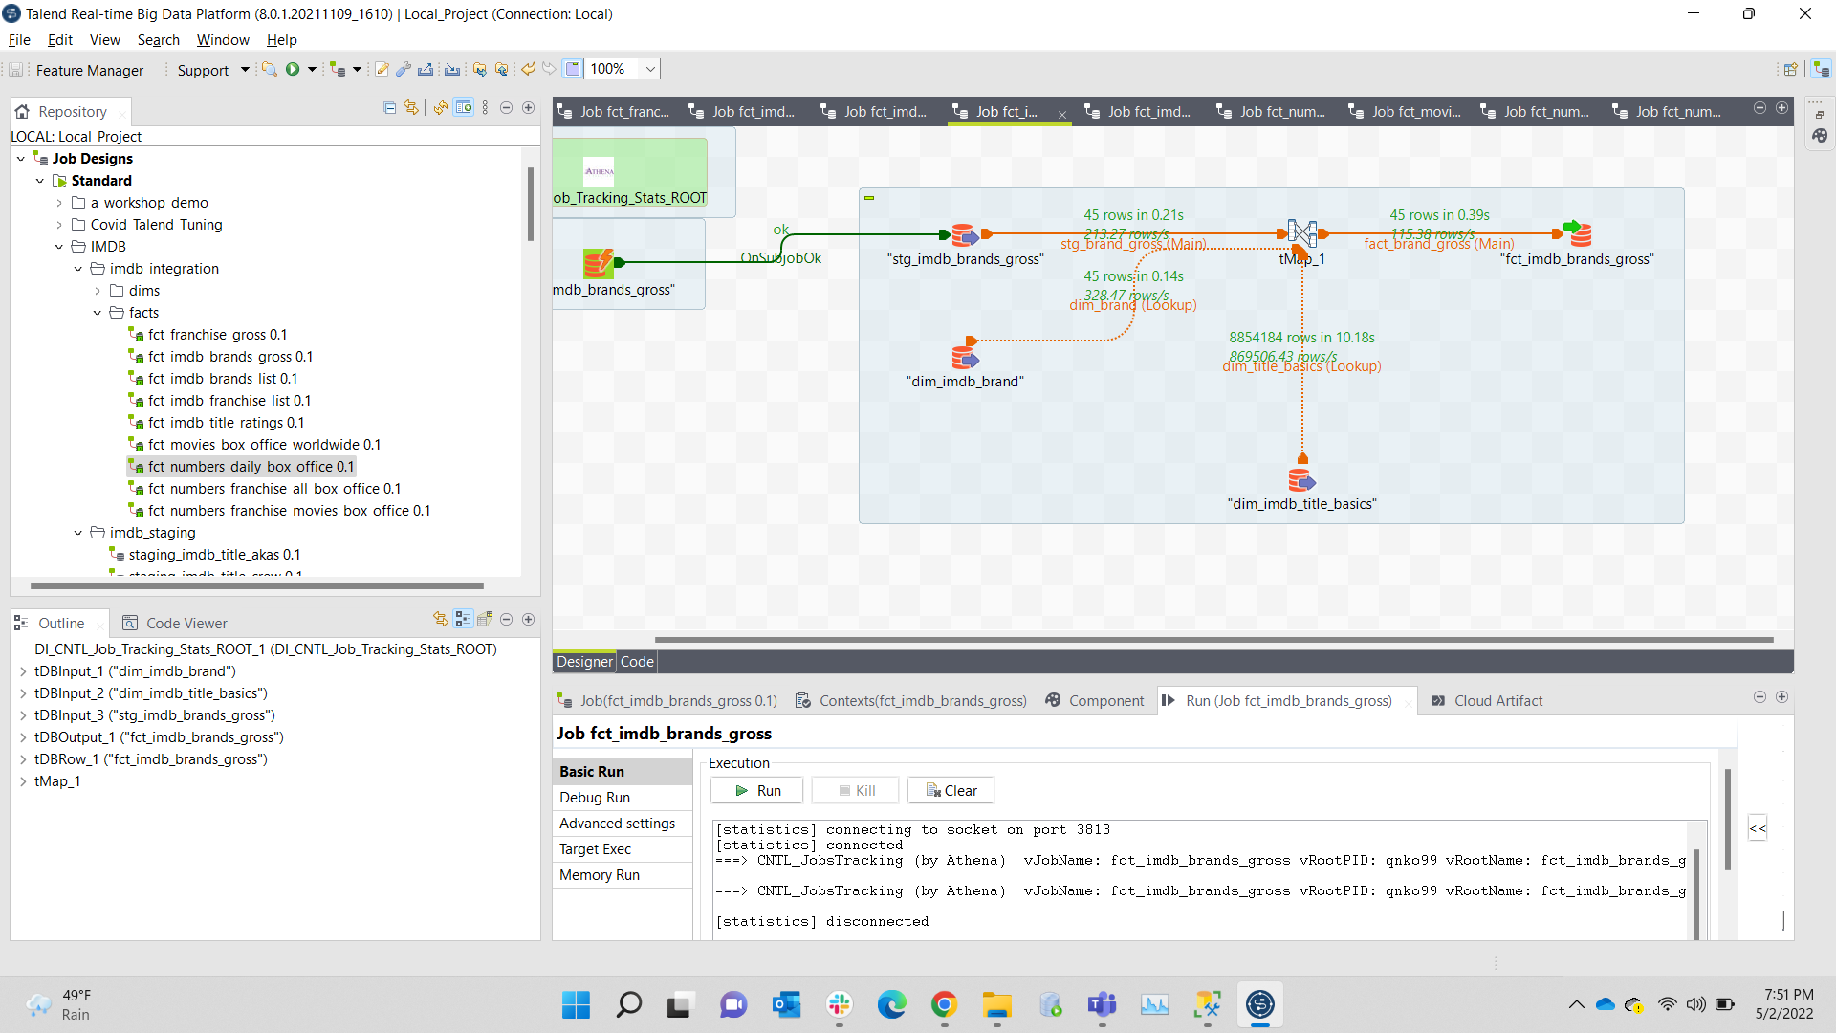

Fct_imdb_brands_list

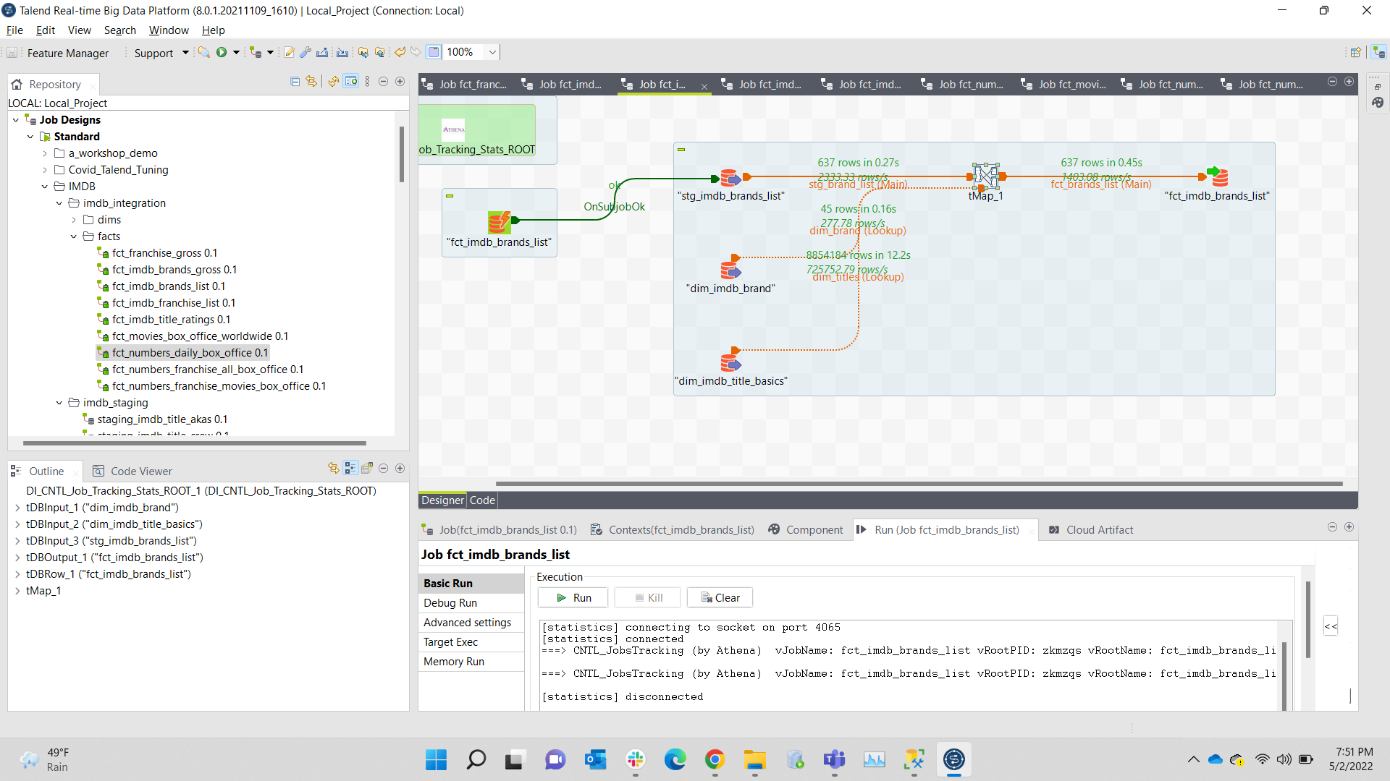

Fct_imdb_franchises_gross

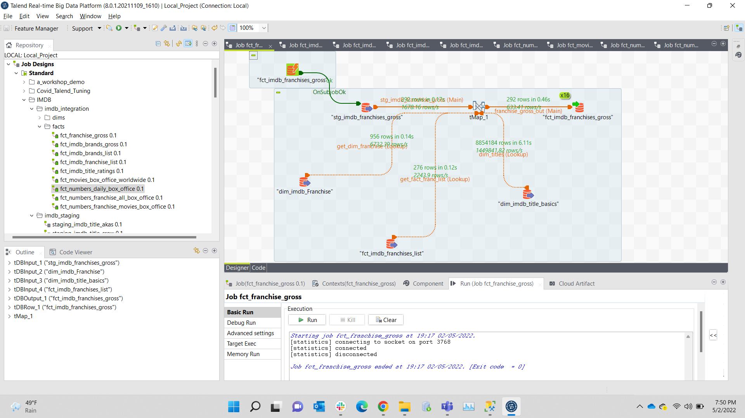

Fct_imdb_franchises_list

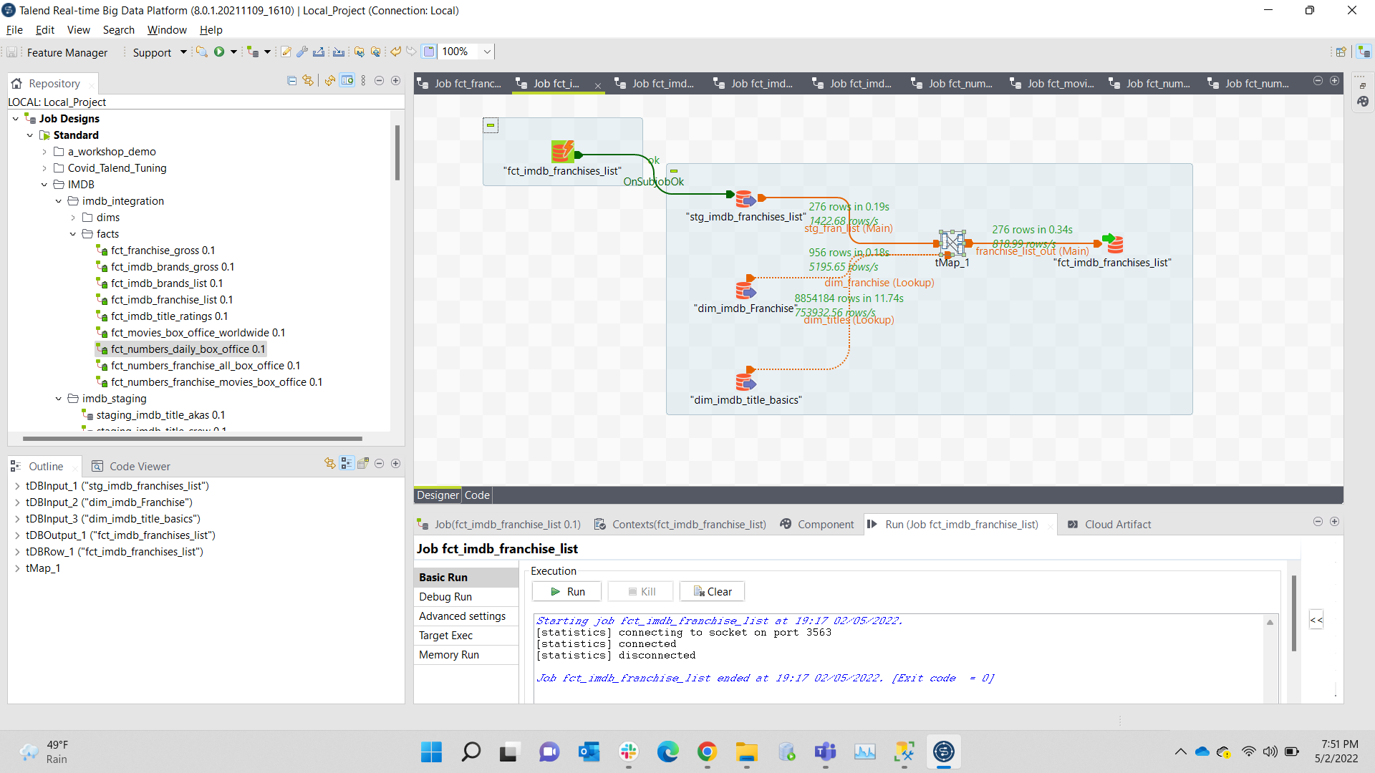

Fct_imdb_title_ratings

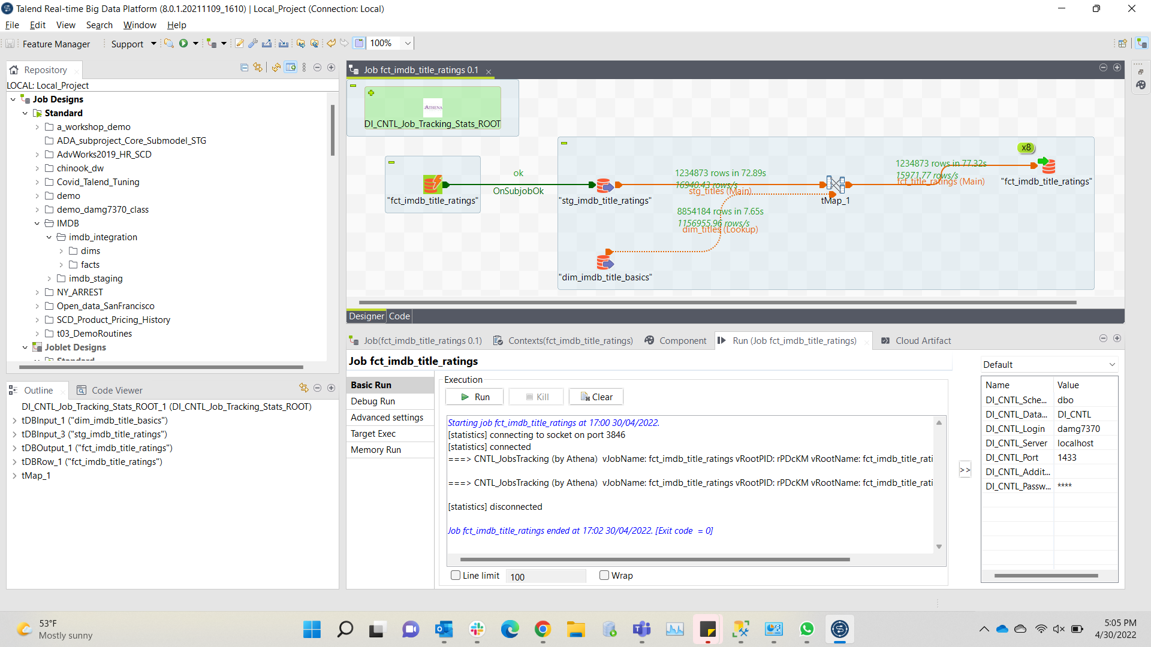

Fct_movies_box_office_worldwide

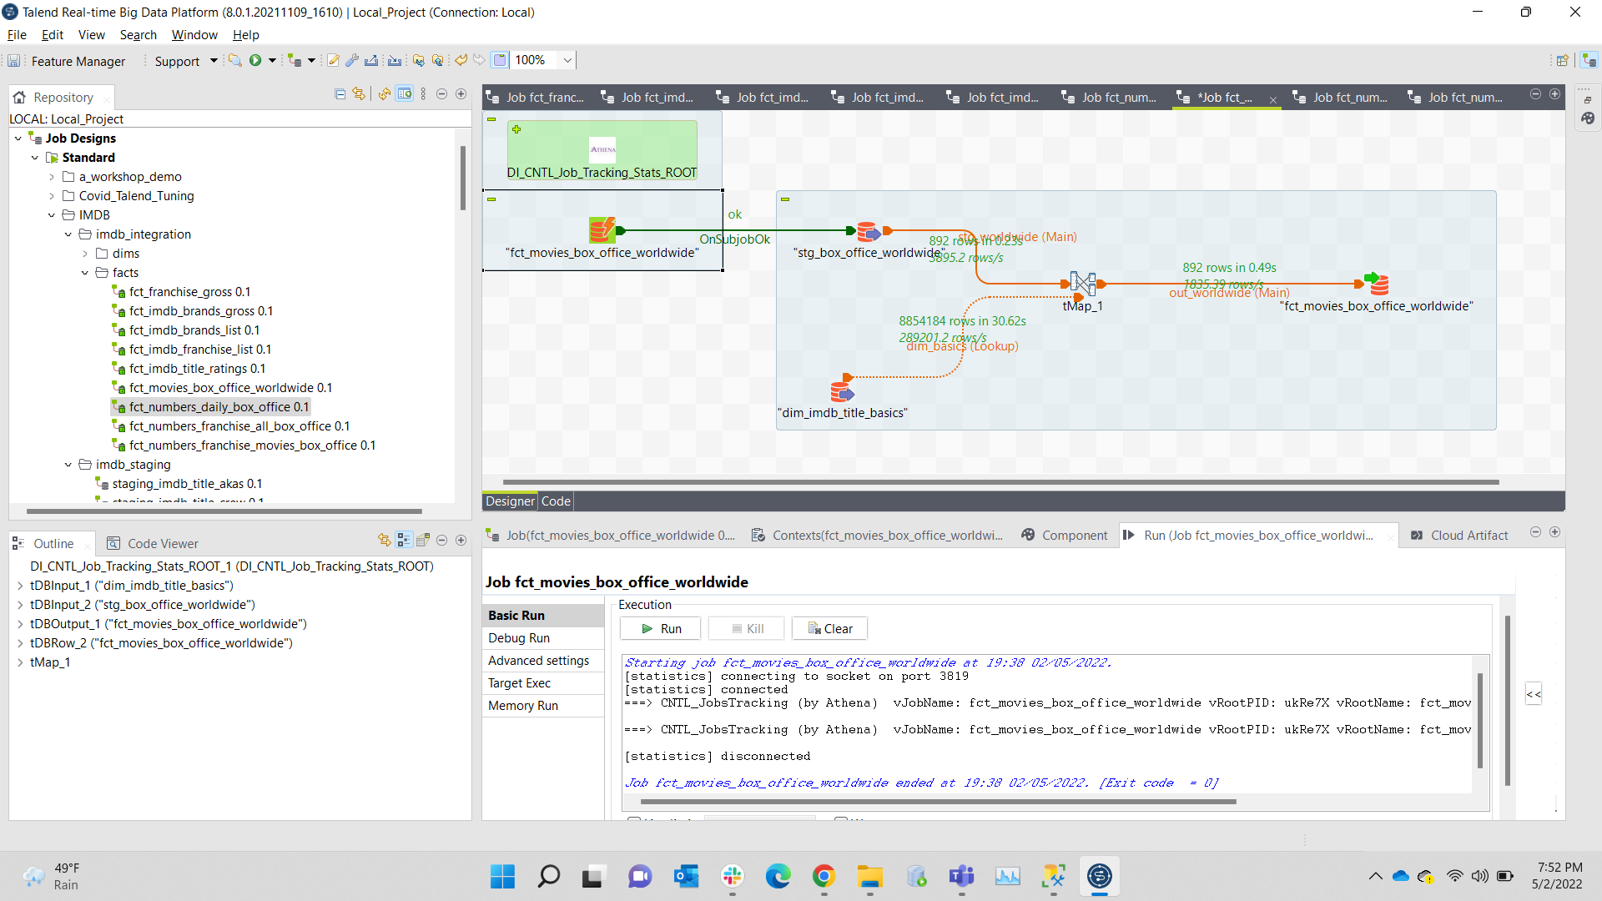

Fct_numbers_daily_box_office

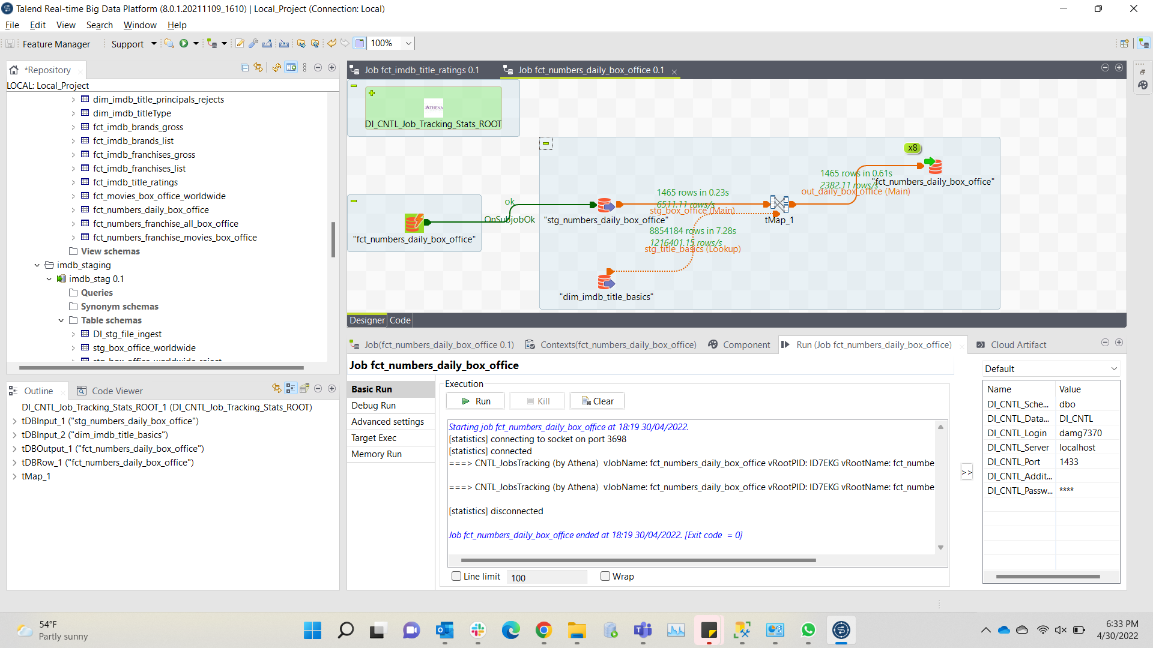

Fct_numbers_franchise_all_box_office

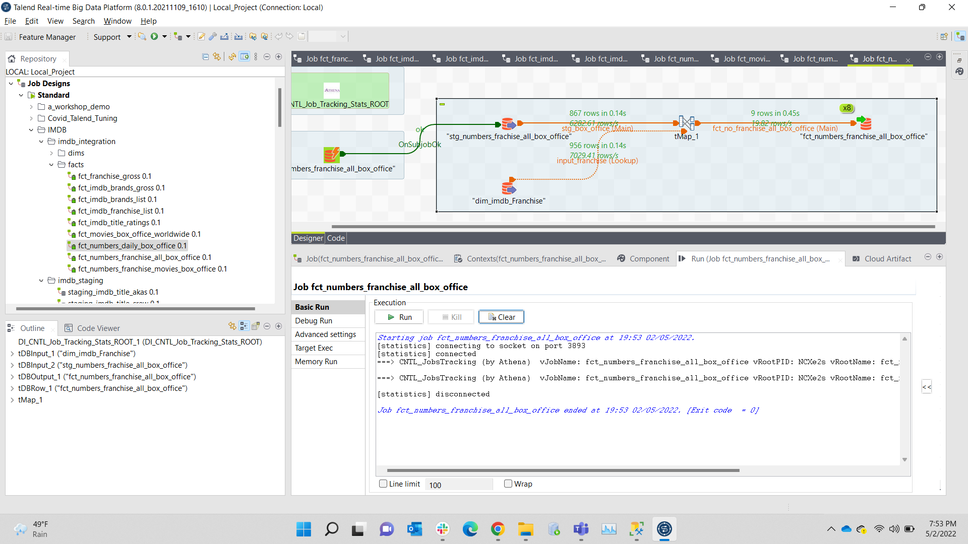

Fct_numbers_franchise_movies_box_office

